# Ass02_pong

**UML DIAGRAM**

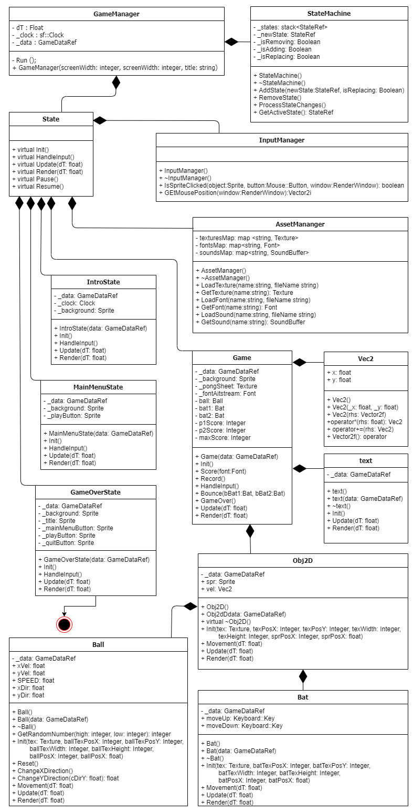

**GAME STATE FLOWCHART**

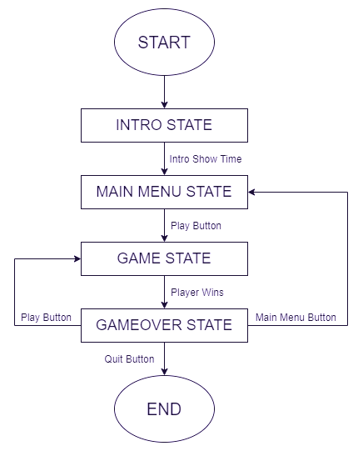

**TEST PLAN**

|  |  |  |  |
| --- | --- | --- | --- |
| INPUT | ACTION | RESULTS | |
| **Expected** | **Results** |
| Left Mouse Button | Activates the button that is placed | Activate the button’s action, i.e. the quit button closes the game window | Activated the button’s action |
| A or a  Key | Move Player 1 bat up | The Player 1’s bat moves upwards | The Player 1’s bat moved upwards |
| W or w  key | Move Player 1 bat down | The Player 1’s bat moves downwards | The Player 1’s bat moved downwards |
| Up Arrow  Key | Move Player 2 bat up | The Player 2’s bat moves upwards | The Player 2’s bat moved upwards |
| Down Arrow  Key | Move Player 2 bat down | The Player 2’s bat moves downwards | The Player 2’s bat moved downwards |